CHAPTER 01

Introduction to Real Time Environmental Parameters Display

Introduction to Real Time Environmental Parameters Display

Air pollution is the biggest problem of every nation, whether it is developed or developing. Health problems have been growing at a faster rate especially in urban areas of developing countries where industrialization and growing number of vehicles leads to release of a lot of gaseous pollutants. Harmful effects of pollution include mild allergic reactions such as irritation of the throat, eyes and nose as well as some serious problems like bronchitis, heart diseases, pneumonia, lung and aggravated asthma. According to a survey, due to air pollution 50,000 to 100,000 premature deaths per year occur in the U.S. alone. Whereas the EU number reaches 300,000 and over 3,000,000 worldwide. Here to make an Air Pollution Monitoring System in which we will monitor the air quality and will trigger an alarm when the air quality goes down beyond a certain level, meaning when there are sufficient amounts of harmful gases present in the air like CO2, smoke, alcohol ,benzene and NH3. It will show the air quality in PPM on the 4 bit LED so that we can monitor it very easily. MQ2 sensor which is the best choice for monitoring Air Quality as it can detect most harmful gases and can measure their amount accurately. When pollution goes beyond some level, it triggers an alert through a buzzer.

BACKGROUND
- Environmental Pollution and Health Risks
Chemicals that are harmful to human health and have gotten into the environment due to human activity are called environmental pollutants. Additionally, environmental pollution is caused by natural events like volcanic eruptions. Human activities introduce pollutants by polluting the water, air, and soil. Inhalation, oral absorption, and ingestion are the three main ways that contaminants reach the human body. Depending on the exposure level, different health effects may result. Although Industrialization develops a country, it introduces a large number of pollutants into the environment, which harms the health of those exposed. Exposure to environmental pollution is a significant source of health risks all over the world.
In general, hazardous substances from both natural and man-made sources pollute the air. The main sources of contaminants include automobile emissions, power plants, burning garbage, chemical companies, and volcanic eruptions contaminants like sulfur dioxide (SO2), carbon monoxide (CO), nitrogen oxides (NOx), heavy metals, biological contaminants, ozone, tobacco smoke, etc. are all released into the air that is inhaled When these pollutants are ingested, they interfere with the body's internal functioning, causing diseases like cancer, cardiovascular, reproductive, prenatal central nervous system, and respiratory health issue. Tobacco smoke, which consists of harmful chemicals like benzene, cadmium, arsenic, formaldehyde, and nicotine is responsible for health illnesses. It will cause cancer, not only to the smoker but also affect passive smoker (who is exposed to tobacco smoke and is not a smoker). A person may develop asthma, bronchitis, throat infection, and a burning sensation in the eyes. Exposure to biological pollutants like bacteria, viruses, house dust, mites, cockroaches, and pollen can cause asthma, hay fever, and other allergic diseases, and volatile organic compounds cause eye, nose, and throat irritation, headaches, nausea, and loss of coordination. Prolonged exposure may cause damage to the parts of the body, mainly the liver. Lead exposure can harm the brain and digestive systems, and in certain circumstances, it can result in cancer. Exposure to ozone causes itching in the eyes, burns, may develop respiratory disorders like asthma, and our resistance to colds and pneumonia will be lowered. In winter, children may suffer from respiratory problems from exposure to oxides of nitrogen. Depending on the exposure's type and intensity, the effect may be either short- or long-term. Short-term effects range from irritation of the eye, skin, nose, and throat, coughing, headaches, nausea, and dizziness to severe conditions like asthma, bronchitis, and lung and heart problems. Long-term effects will be neurological, reproductive, respiratory, and cancer.

Importance of Real-Time Monitoring
Real-time monitoring of environmental parameters is crucial for maintaining a safe and healthy living and working environment. Air quality and atmospheric conditions such as CO₂ levels, dust particles, temperature, and humidity can change rapidly, and delayed detection may lead to health hazards or uncomfortable conditions. Continuous monitoring allows for instant detection of unsafe levels, enabling timely alerts and preventive measures to reduce exposure to harmful pollutants. Unlike periodic or manual monitoring methods, real-time systems provide continuous data acquisition and immediate feedback, ensuring that corrective actions can be taken without delay. This is particularly important in indoor spaces, industrial areas, laboratories, and public buildings, where rapid changes in air quality can significantly affect the safety and well-being of occupants.
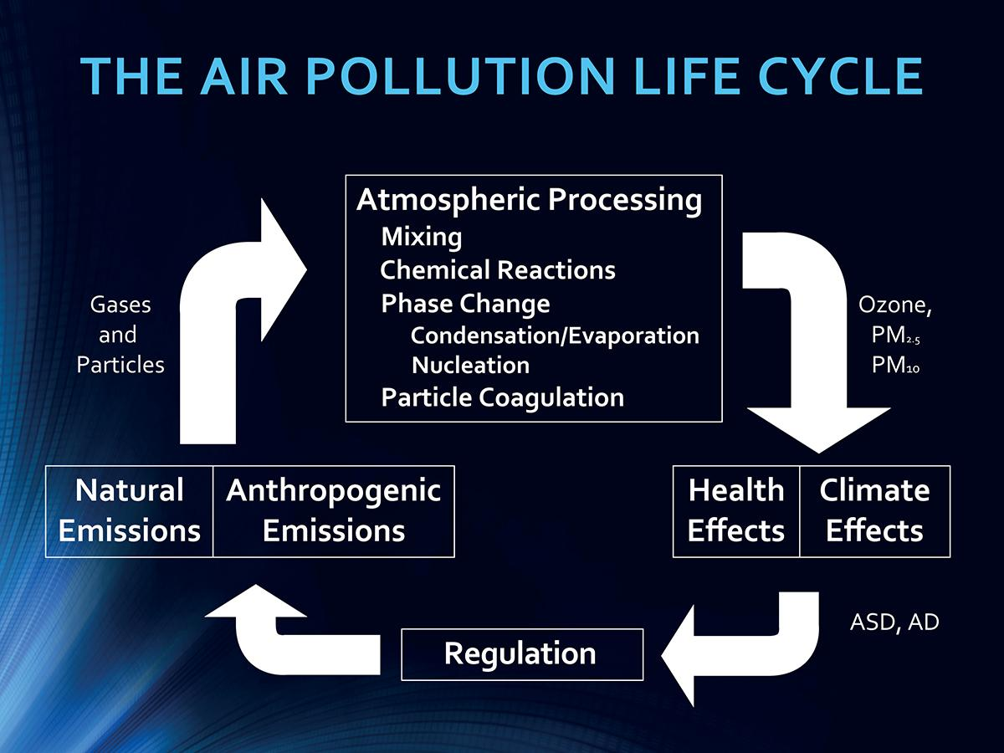
Fig 1.1 Air pollution life cycle

Need for Alerts and Automation
The implementation of threshold-based alert systems is essential for ensuring immediate awareness of hazardous environmental conditions. In scenarios where parameters such as CO₂ concentration, dust particle levels, temperature, and humidity exceed safe limits, timely notification can prevent health risks, discomfort, and even serious emergencies. Manual monitoring is often insufficient because environmental conditions can change rapidly, making continuous human supervision impractical and unreliable. By incorporating automated alerts, such as buzzers, LEDs, or notifications through connected platforms, the system can provide instant warnings without human intervention. Furthermore, automation reduces the reliance on constant human observation, enabling safer operation in indoor, industrial, and public spaces where air quality and environmental parameters directly impact human health and productivity. Combining real-time monitoring with automated alerts not only enhances safety but also ensures that preventive actions can be taken promptly, creating a more efficient and proactive approach to environmental management.

CHAPTER 2

Objectives Of Project

OBJECTIVES OF PROJECT

The objectives of this project are:
- To design and develop an embedded system for real-time monitoring of environmental parameters.
- To measure CO₂ concentration and dust particle levels using MQ2 sensors.
- To monitor temperature and humidity using the DHT11 sensor.
- To process and display sensor data continuously using an ESP 32 controller.
- To implement a threshold-based alert system using a buzzer for hazardous conditions.
- To provide a low-cost and reliable solution for environmental safety monitoring.
- To enhance awareness and timely response to unsafe environmental conditions.
THESIS ORGANIZATION

This thesis consists of 7 main chapters, including this part as chapter 1 and the other part of the document is listed as follows:
Chapter 1: In this chapter, we discussed the introduction of the proposed system, then the background, objective, problem statement of the project.
Chapter 2: In this chapter, we discussed the literature review.
Chapter 3: In this chapter, we saw the research methodology. In which we discussed the algorithm used, and the flow chart of the system.
Chapter 4: In this chapter we saw the software requirements.
Chapter 5 : In this chapter, we discussed the implementation, result part of the project.
Chapter 6: In this project, we discussed the conclusion and future scope.
Chapter 7: This is the last chapter of the thesis which included references.

CHAPTER 3

Literature Survey

Literature Survey

- M. DEEPSHIKA et al. studies commonly utilize embedded systems and IoT-based platforms with microcontrollers such as Arduino and ESP modules integrated with MQ series gas sensors to detect harmful gases like CO₂, CO, and other air pollutants. Temperature and humidity sensors such as DHT11 are often incorporated to analyze environmental conditions influencing air quality. Many proposed systems include threshold-based alert mechanisms using buzzers, LEDs, or mobile notifications to warn users when pollution levels exceed safe limits. Recent advancements emphasize cloud connectivity for data logging and remote visualization through web or mobile applications. These studies demonstrate that real-time monitoring systems provide a cost-effective, reliable, and efficient solution for continuous environmental surveillance, forming a strong foundation for the proposed system.[1]
- Thanushree D. and Vaishnavi G. presented an air quality detection system using embedded technology aimed at monitoring environmental pollution in real time. Their work focuses on the integration of a microcontroller-based system with gas sensors from the MQ series to detect harmful air pollutants and assess air quality levels effectively. The system continuously monitors parameters such as gas concentration and environmental conditions, providing timely feedback through display or alert mechanisms. The study highlights the advantages of using embedded systems for air quality monitoring due to their low cost, simplicity, and real-time response capability. This research demonstrates the practicality of embedded solutions in environmental monitoring applications and contributes to the development of efficient air quality detection systems for indoor and outdoor environments.[2]
- Yeshvant B.A. presented a real-time temperature and humidity monitoring system using embedded system technology to continuously observe environmental conditions. The proposed system integrates a microcontroller with temperature and humidity sensors such as DHT series sensors, enabling accurate and real-time data acquisition. The monitored parameters are displayed instantly, allowing users to track changes in environmental conditions efficiently. The study emphasizes the importance of real-time monitoring in applications such as indoor climate control, agriculture, and industrial environments. By utilizing a low-cost embedded platform, the system demonstrates a reliable, economical, and user-friendly solution for continuous temperature and humidity monitoring.[3]
- Fatima Khan proposed an IoT-driven pollution detection system designed to monitor air quality in both indoor and outdoor environments using smart sensing and internet connectivity. The system integrates various environmental sensors to measure pollution parameters and transmits the collected data to an IoT platform for real-time monitoring and analysis. By leveraging IoT technology, the system enables remote access, continuous data logging, and timely alerts when pollution levels exceed permissible limits. The study highlights the effectiveness of IoT-based solutions in improving environmental awareness, enhancing decision-making, and providing scalable, low-cost monitoring for smart homes, cities, and industrial areas. This work demonstrates how IoT significantly enhances traditional pollution monitoring systems through real-time visibility and connectivity.[4]
- Osama Alsamrai proposed a real-time intelligent air quality monitoring system for urban environments by combining IoT sensing technology with machine learning algorithms. The system collects air pollution data from multiple sensors and transmits it to a cloud-based platform for real-time analysis and visualization. Machine learning models are used to predict pollution trends, detect anomalies, and provide actionable insights, enhancing decision-making for environmental management. The study demonstrates that integrating IoT with predictive analytics can significantly improve air quality monitoring by providing timely alerts, long-term trend analysis, and data-driven recommendations for mitigating urban pollution. This work highlights the potential of intelligent, connected systems in building smarter and healthier cities.[5]
- Tanishq Kale proposed a real-time industrial pollution monitoring system that utilizes IoT-enabled sensors to continuously measure air quality parameters such as harmful gas concentrations, particulate matter, and environmental conditions in industrial settings. The system transmits collected data to a cloud platform, enabling remote monitoring, real-time visualization, and data logging. Alerts are generated automatically when pollutant levels exceed safe thresholds, allowing timely intervention to reduce environmental and health risks. The study highlights the effectiveness of IoT-based solutions for industrial environmental management, providing a low-cost, scalable, and automated approach for continuous pollution monitoring and regulatory compliance.[6]
- Manuel Méndez presented a comprehensive survey on machine learning algorithms for air quality forecasting, highlighting how predictive models can improve the accuracy and efficiency of environmental monitoring systems. The study reviews techniques such as regression models, neural networks, and ensemble learning methods for predicting pollution levels based on historical sensor data. These machine learning approaches enable proactive measures by anticipating high pollution events, optimizing resource allocation, and generating timely alerts. The survey emphasizes the integration of IoT-collected data with predictive algorithms to create smart and intelligent air quality monitoring systems, demonstrating the potential of combining real-time sensing with data-driven analytics for urban, industrial, and environmental management applications.[7]
- Darshini Rajasekar proposed an IoT-based air quality monitoring system integrated with machine learning algorithms to not only track environmental pollution but also predict potential health impacts. The system collects real-time data on air pollutants such as CO₂, CO, and particulate matter using connected sensors and transmits it to a cloud platform for analysis. Machine learning models are applied to correlate pollution levels with health risks, enabling disease prediction and early warnings for respiratory and other pollution-related conditions. This approach demonstrates the benefits of combining IoT-enabled sensing with predictive analytics to provide timely alerts, improve public health awareness, and facilitate proactive measures for mitigating the effects of poor air quality.[8]
- J. Prayudha, et al. researchers created a system that can measure air quality by combining the IoT concept and the fuzzy intelligence method in their research using Arduino Uno. The results of this study are more accurate than conventional measurements, but, in this study, the speed of the internet greatly affects the web-based server in making changes to the latest information (updates), so it requires an internet service that has optimal speed, as well as sufficient device server support. This paper does not specify any specific sensor, and only focuses on fuzzy logic implementation.[9]

- N. Middinali et al. proposed module is used as a sensor that works to monitor air quality. The application will process data in the form of numbers which are sent to the MySQL database to be uploaded to the internet network in accordance with the ISPU (Air Pollution Standard Index) for further display on the website. This research only monitors the presence of PM10, O3, and CO in the air using MiCS2610.[10]

CHAPTER 4

System Architecture

System Architecture

BLOCK DIAGRAM

BUZZER
ESP 32
MICROCONTROLLER
DHT11 SENSOR
MQ2 SENSOR
LED 1
LED 2
LED 3
LED 4

Fig 4.1 shows the block diagram of the project

DESCRIPTION
In this project we have used an ESP32 Microcontroller. In input we have MQ2 Sensor and DHT11 Sensor. In output we have four 4 bit LED displays and buzzer for alert generation.

FLOWCHART

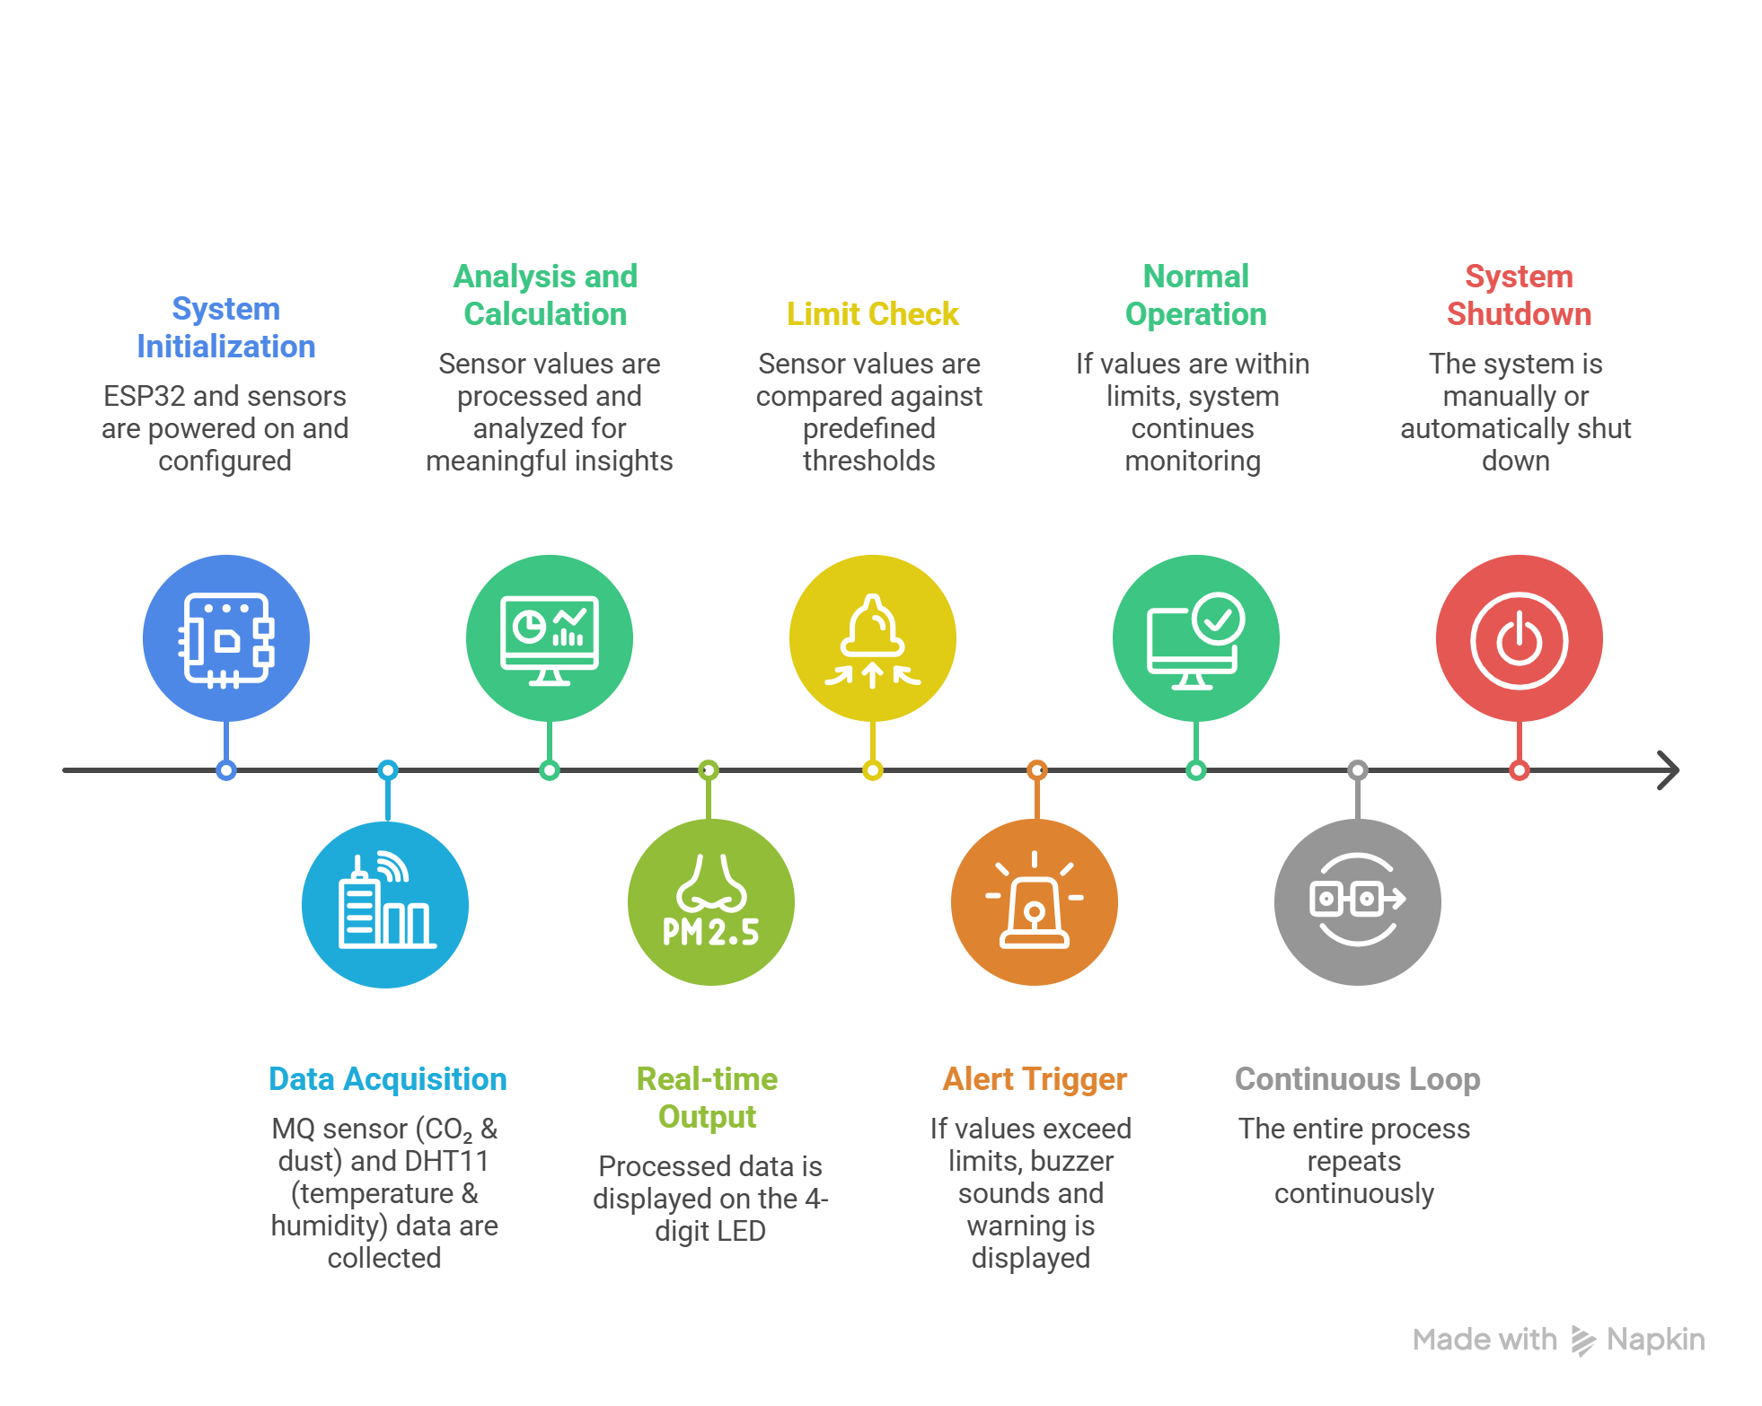

Fig 4.2 shows the flowchart of the system

WORKING
The proposed system works by continuously monitoring environmental parameters using the ESP32 microcontroller as the central processing unit. Initially, all sensors including the MQ2 sensor and DHT11 sensor are initialized. The MQ2 sensor detects the concentration of CO₂ and dust particles in the air, while the DHT11 sensor measures temperature and humidity. These sensor readings are collected by the ESP32 and processed in real time. The processed data is then displayed on a 4-digit LED display, allowing users to easily observe current environmental conditions.
The system continuously compares the sensed values with predefined threshold limits to determine air quality safety levels. If any parameter such as gas concentration, temperature, or humidity exceeds the safe limit, the ESP32 immediately activates a buzzer to alert users about the unsafe condition. At the same time, the warning values are displayed on the 4 bit LED display for quick identification. If all parameters are within safe limits, the system continues normal monitoring without triggering any alert.
This process runs continuously in a loop, ensuring real-time monitoring and quick response to environmental changes. The system is efficient, user-friendly, and suitable for maintaining a safe and healthy environment in indoor spaces such as homes, offices, classrooms, and industrial areas.

CHAPTER 5

Requirements

Requirements

The proposed system is classified into tow setups

5.1 Hardware Requirements
5.2 Software Requirements

5.1 HARDWARE REQUIREMENTS :
HARDWARE REQUIREMENT
- ESP32 Microcontroller
- MQ2 Sensor
- DHT 11 Sensor
- Buzzer
- TM1637 4 Bits LED Display * 4

5.2 SOFTWARE REQUIREMENTS
- Arduino IDE
- Proteus

ESP 32

ESP32 is the SoC (System on Chip) microcontroller that has gained massive popularity recently. Whether the popularity of ESP32 grew because of the growth of IoT or whether IoT grew because of the introduction of ESP32 is debatable.

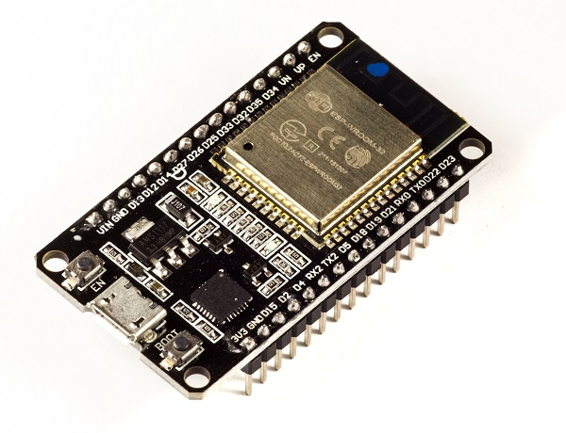
Fig 5.1 : ESP32
Before we delve into the actual reasons for the popularity of ESP32, let's take a look at some of its important specifications. The specs listed below belong to the ESP32 WROOM 32 variant.−
- Integrated Crystal− 40 MHz
- Module Interfaces− UART, SPI, I2C, PWM, ADC, DAC, GPIO, pulse counter, capacitive touch sensor
- Integrated SPI flash− 4 MB
- ROM− 448 KB (for booting and core functions)
- SRAM− 520 KB
- Integrated Connectivity Protocols− WiFi, Bluetooth, BLE
- On−chip sensor− Hall sensor
- Operating temperature range− −40 − 85 degrees Celsius
- Operating Voltage− 3.3V
- Operating Current− 80 mA (average)

With the above specifications in front of you, it is very easy to decipher the reasons for ESP32's popularity. Consider the requirements an IoT device would have from its microcontroller (μC). If you've gone through the previous chapter, you'd have realized that the major operational blocks of any IoT device are sensing, processing, storage, and transmitting. Therefore, to begin with, the μC should be able to interface with a variety of sensors. It should support all the common communication protocols required for sensor interface: UART, I2C, and SPI. It should have ADC and pulse-counting capabilities. ESP32 fulfills all of these requirements. On top of that, it also can interface with capacitive touch sensors. Therefore, most common sensors can interface seamlessly with ESP32.
Secondly, the μC should be able to perform basic processing of the incoming sensor data, sometimes at high speeds, and have sufficient memory to store the data. ESP32 has a max operating frequency of 40 MHz, which is sufficiently high. It has two cores, allowing parallel processing, which is a further add-on. Finally, its 520 KB SRAM is sufficiently large for processing a large array of data onboard. Many popular processes and transforms, like FFT, peak detection, RMS calculation, etc. can be performed onboard ESP32. On the storage front, ESP32 goes a step ahead of the conventional microcontrollers and provides a file system within the flash. Out of the 4 MB of onboard flash, by default, 1.5 MB is reserved as SPIFFS (SPI Flash File System). Think of it as a mini−SD Card that lies within the chip itself. You can not only store data, but also text files, images, HTML and CSS files, and a lot more within SPIFFS. People have displayed beautiful Webpages on WiFi servers created using ESP32, by storing HTML files within SPIFFS.
Finally, for transmitting data, ESP32 has integrated WiFi and Bluetooth stacks, which have proven to be game-changers. No need to connect a separate module (like a GSM module or an LTE module) for testing cloud communication. Just have the ESP32 board and a running WiFi, and you can get started. ESP32 allows you to use WiFi in Access Point as well as Station Mode. While it supports TCP/IP, HTTP, MQTT, and other traditional communication protocols, it also supports HTTPS. Yep, you heard that right. It has a crypto−core or a crypto-accelerator, a dedicated piece of hardware whose job is to accelerate the encryption process. So you cannot only communicate with your web server, you can do so securely. BLE support is also critical for several applications. Of course, you can interface LTE or GSM or LoRa modules with ESP32. Therefore, on the 'transmitting data' front as well, ESP32 exceeds expectations.
With so many features, ESP32 would be costing a fortune, right? That's the best part. ESP32 dev modules cost in the ballpark of ₹ 500. Not only that, the chip dimensions are quite small (25 mm x 18 mm, including the antenna area), allowing its use in devices requiring a very small form factor.

DHT 11 SENSOR

DHT11 is a Humidity and Temperature Sensor, which generates calibrated digital output. DHT11 can interface with any microcontroller like Arduino, Raspberry Pi, etc. and get instantaneous results. DHT11 is a low cost humidity and temperature sensor which provides high reliability and long term stability.
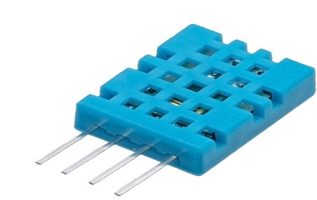
Fig 5.2 : DHT11 Sensor
It uses a capacitive humidity sensor and a thermistor to measure the surrounding air, and outputs a digital signal on the data pin (no analog input pins needed). Its very simple to use, and libraries and sample codes are available for Arduino and Raspberry Pi.
This module makes it easy to connect the DHT11 sensor to an Arduino or microcontroller as it includes the pull up resistor required to use the sensor. Only three connections are required to be made to use the sensor - Vcc, Gnd and Output.
It has high reliability and excellent long-term stability, thanks to the exclusive digital signal acquisition technique and temperature & humidity sensing technology.

Specifications:-
- Power Supply： 3.3~5.5V DC
- Output： 4 pin single row
- Measurement Range： Humidity 20-90%RH， Temperature 0~50℃
- Accuracy： Humidity +-5%RH， Temperature +-2℃
- Resolution： Humidity 1%RH， Temperature 1℃
- Interchangeability： Fully Interchangeable
- Long-Term Stability： <±1%RH/year

Pin Description:-
- Pin 1: Power +Ve (3.3VDC to 5.5VDC Max wrt. GND)
- Pin 2: Serial Data Output
- Pin 3: Power Ground or Power –Ve

MQ SENSOR
MQ Series are a set of gas sensors that are used to identify different types of gases. They are very useful in measuring the gas concentration and can be used in sensitive areas such as chemical industries. Each type of MQ sensor is designed to detect specific gases. We’ve a lot of MQ sensors. Some most commonly used ones are:-
A MQ sensor has 4 pins and many other components, depicted in the image below :
Sensor | Used in the detection of
MQ-2 | Combustible gas, smoke
MQ-3 | Alcohol
MQ-4 | Methane, propane, butane
MQ-5 | Natural gas, LPG
MQ-6 | Propane, LPG
MQ-7 | Carbon monoxide
MQ-8 | Hydrogen
MQ-9 | Carbon monoxide, methane
MQ-135 | Ammonia sulfide, benzene vapour

A MQ sensor has 4 pins and many other components, depicted in the image below

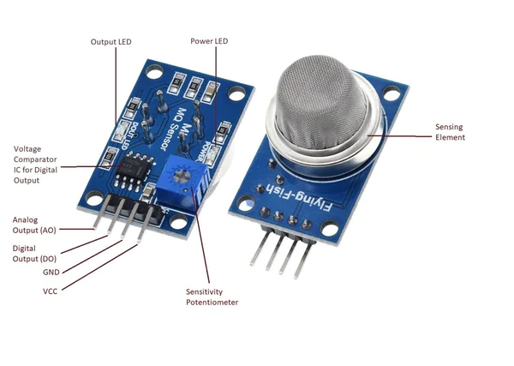
Fig 5.3 : MQ135 Sensor

BUZZER

An audio signaling device like a beeper or buzzer may be electromechanical or piezoelectric or mechanical. The main function of this is to convert the signal from audio to sound. Generally, it is powered through DC voltage and used in timers, alarm devices, printers, alarms, computers, etc. Based on the various designs, it can generate different sounds like alarms, music, bell & siren

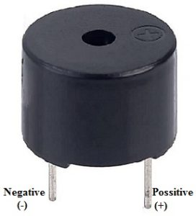
Fig 5.4 : Buzzer
The pin configuration of the buzzer is shown below. It includes two pins namely positive and negative. The positive terminal of this is represented with the ‘+’ symbol or a longer terminal. This terminal is powered through 6 Volts whereas the negative terminal is represented with the ‘-‘symbol or short terminal and it is connected to the GND terminal.

Specifications
The specifications of the buzzer include the following.
- Color is black
- The frequency range is 3,300Hz
- Operating Temperature ranges from – 20° C to +60°C
- Operating voltage ranges from 3V to 24V DC
- The sound pressure level is 85dBA or 10cm
- The supply current is below 15mA
TM1637 DISPLAY
TM1637 is a kind of LED (light-emitting diode display) drive control special circuit with keyboard scan interface and its internally integrated MCU digital interface, data latch, LED high pressure drive and keyboard scan.
The TM1637 4 Bits Digital Tube LED Display Module is an affordable solution for displaying the output data of your Arduino project. Though the data displayed is restricted by numbers still it allows users to display some characters too like A, B, C etc.
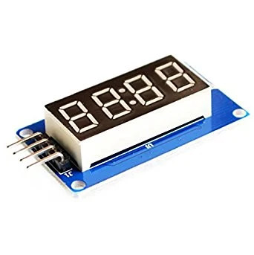
This 7 segment LED Display has 4 digits which are controlled by TM1637 Driver Chip. It requires only two connections to control this TM1637 4 Bits Digital Tube LED Display Module.

Fig 5.5 : TM1637 Display

TM1637 is a chip for driving 7-segment displays. There are several modules using this chip to form a 4 digit numerical display module. TM1637 also has keyboard input capability, but is not used in this module.

Features of TM1637 based 4 Bits Red Digital Tube LED Display Module:
- Ease to use.
- Ease of multiplexing.
- Can be used as a 4 digit display unit.
- Can be used as a clock display.

Applications of TM1637 based 4 Bits Red Digital Tube LED Display Module:
- DIY clock project.
- 4 digit display unit.
- Electrical/Electronic projects.
- Counter project using 7 segment display.
Hardware Connection
The display module has 4 pins:
- VCC & GND - Self explanatory
- CLK - Clock; connect to any digital pin on the Arduino
- DIO - Data I/O; connect to any digital pin on the Arduino
SPECIFICATION
- Driver Chip: MAX7219
- Input Voltage: 3.7 to 5.3 V
- Input Current: 30 mA
- Display Dimensions: 42x24x12 (LxWxH) mm

5.2 ARDUINO IDE SOFTWARE INTRO

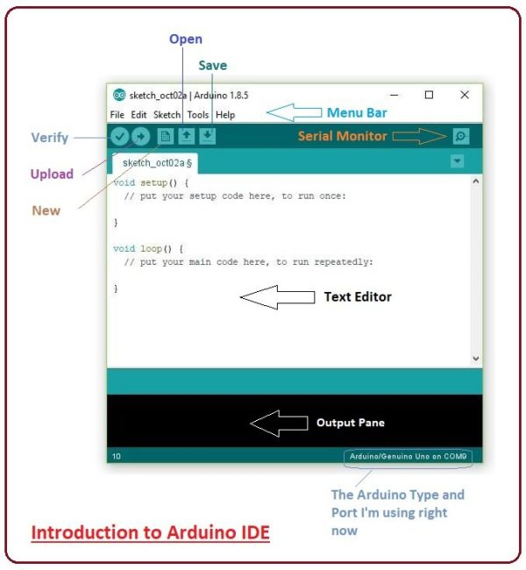

An official software introduced by Arduino.cc, that is mainly used for writing, compiling and uploading the code in almost all Arduino modules/boards. Arduino IDE is open-source software and is easily available to download & install.

- Arduino IDE is an open-source software, designed by Arduino.cc and mainly used for writing, compiling & uploading code to almost all Arduino Modules.
- It is an official Arduino software, making code compilation so easy that even a common person with no prior technical knowledge can get their feet wet with the learning process.
- It is available for all operating systems i.e. MAC, Windows, Linux and runs on the Java Platform that comes with inbuilt functions and commands that play a vital role in debugging, editing and compiling the code.
- A range of Arduino modules available including Arduino Uno, Arduino Mega, Arduino Leonardo, Arduino Micro and many more.
- Each of them contains a microcontroller on the board that is actually programmed and accepts the information in the form of code.
- The main code, also known as a sketch, created on the IDE platform will ultimately generate a Hex File which is then transferred and uploaded in the controller on the board.
- The IDE environment mainly contains two basic parts: Editor and Compiler where the former is used for writing the required code and later is used for compiling and uploading the code into the given Arduino Module.
- This environment supports both C and C++ languages.
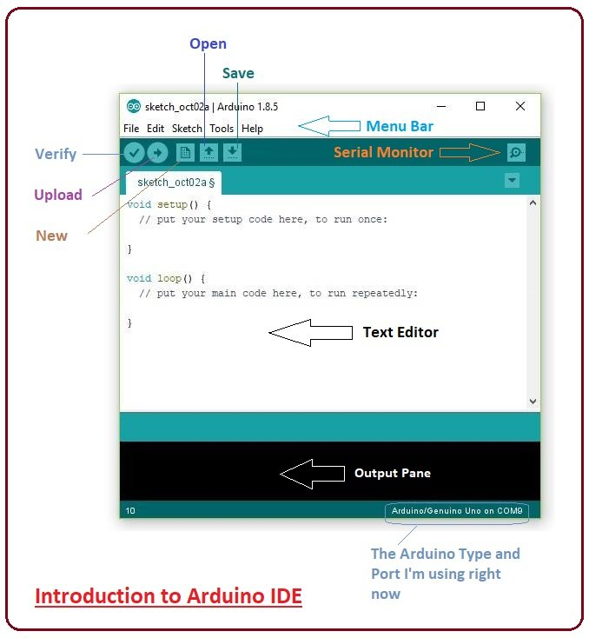
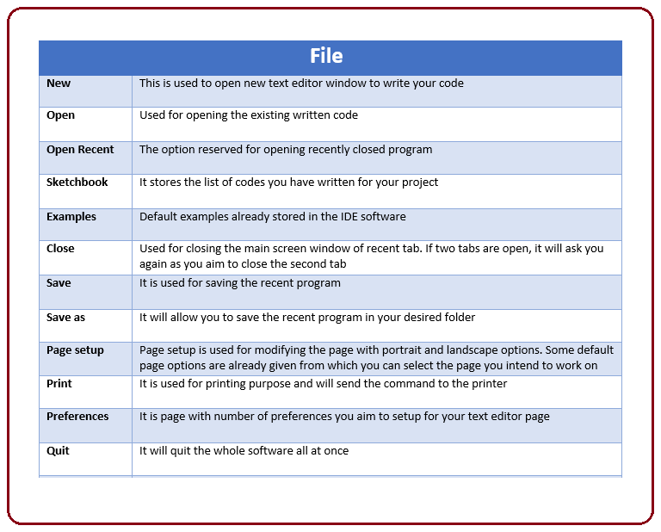
- As you go to the preference section and check the compilation section, the Output Pane will show the code compilation as you click the upload button.
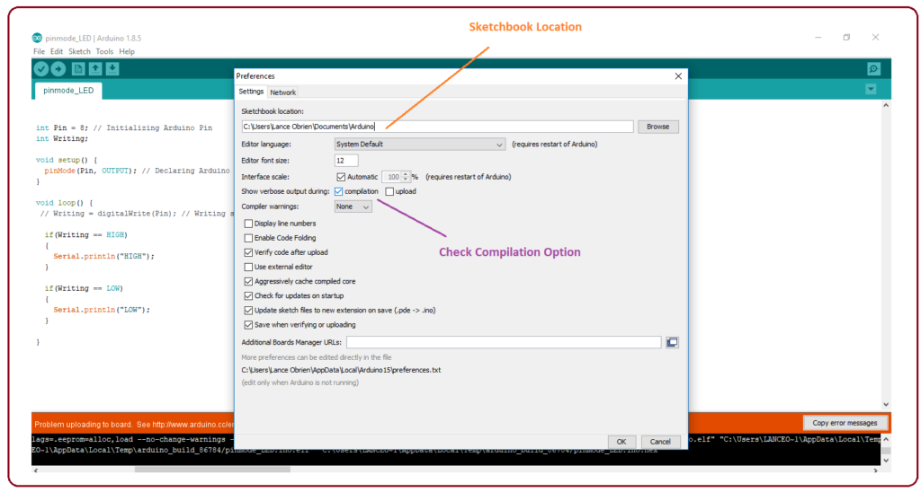
- And at the end of the compilation, it will show you the hex file it has generated for the recent sketch that will be sent to the Arduino Board for the specific task you aim to achieve.
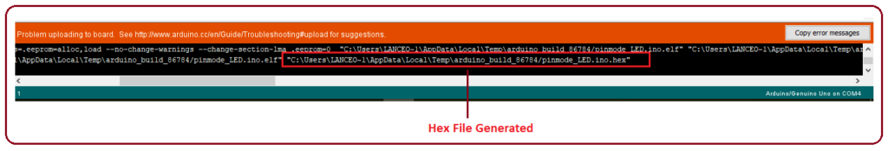
- Edit – Used for copying and pasting the code with further modification for font
- Sketch – For compiling and programming
- Tools – Mainly used for testing projects. The Programmer section in this panel is used for burning a bootloader to the new microcontroller.
- Help – In case you are feeling skeptical about software, complete help is available from getting started to troubleshooting.
The Six Buttons appearing under the Menu tab are connected with the running program as follows.

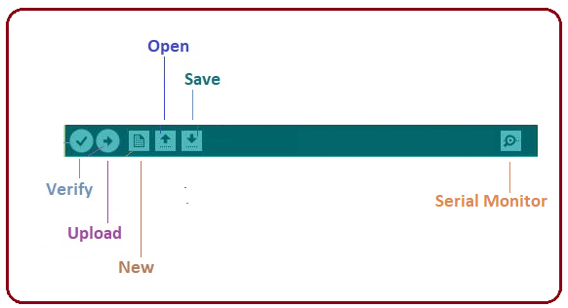

- The check mark appearing in the circular button is used to verify the code. Click this once you have written your code.
- The arrow key will upload and transfer the required code to the Arduino board.
- The dotted paper is used for creating a new file.
- The upward arrow is reserved for opening an existing Arduino project.
- The downward arrow is used to save the current running code.
- The button appearing on the top right corner is a Serial Monitor – A separate pop-up window that acts as an independent terminal and plays a vital role in sending and receiving the Serial Data. You can also go to the Tools panel and select Serial Monitor, or pressing Ctrl+Shift+M all at once will open it instantly. The Serial Monitor will actually help to debug the written Sketches where you can get a hold of how your program is operating. Your Arduino Module should be connected to your computer by USB cable in order to activate the Serial Monitor.

- You need to select the baud rate of the Arduino Board you are using right now. For my Arduino Uno Baud Rate is 9600, as you write the following code and click the Serial Monitor, the output will show as the image below.
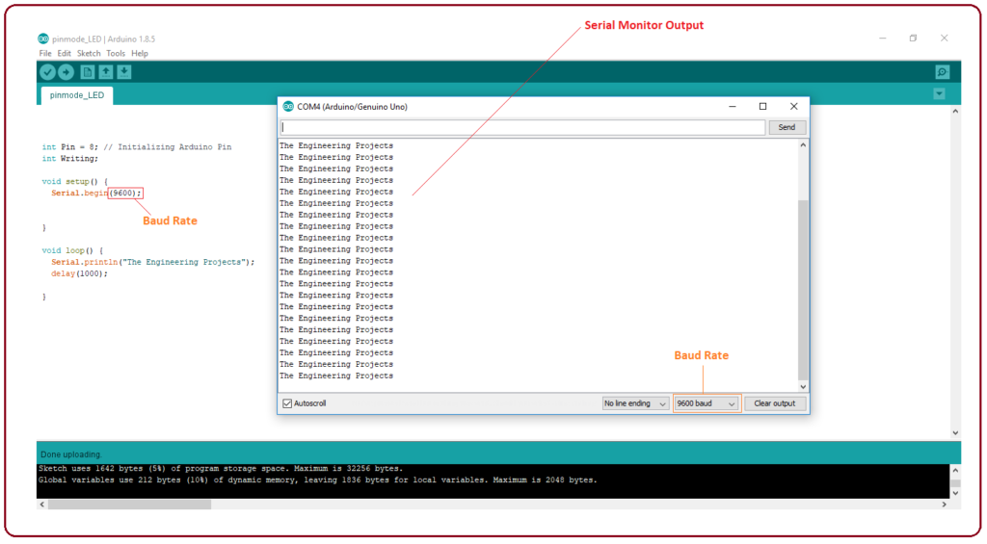

PROTEUS SOFTWARE
It is a software suite containing schematic, simulation as well as PCB designing.
- ISIS is the software used to draw schematics and simulate the circuits in real-time. The simulation allows human access during run time, thus providing real-time simulation.
- ARES is used for PCB designing. It has the feature of viewing the output in a 3D view of the designed PCB along with the components.
- The designer can also develop 2D drawings for the product.

CHAPTER 6

Implementation And Results

IMPLEMENTATION AND RESULTS

The implementation designed to provide real-time monitoring of environmental parameters using an embedded system platform. It is based on the ESP32 microcontroller, which serves as the central controller for processing sensor data and controlling alert mechanisms. The system integrates an MQ2 sensor to detect CO₂ levels and dust particles, providing an accurate measure of air quality. Additionally, a DHT11 sensor is used to monitor temperature and humidity, giving a complete view of environmental conditions.
All sensor data is continuously read and processed by the controller. To enhance user interaction, a 4 Bits LED display is added to show real-time values of parameters such as temperature, humidity, and air quality levels. This allows users to easily view the readings directly on the device. When any parameter exceeds its predefined threshold, the system immediately triggers a buzzer alert while also displaying the warning values on the LED display, notifying users of unsafe conditions.
The proposed system is portable, cost-effective, and easy to deploy, making it suitable for indoor environments, offices, classrooms, or industrial settings where monitoring air quality is crucial. By combining multiple sensors, a LED display, and real-time alerts, the system ensures timely awareness and helps in maintaining a safe and healthy environment.
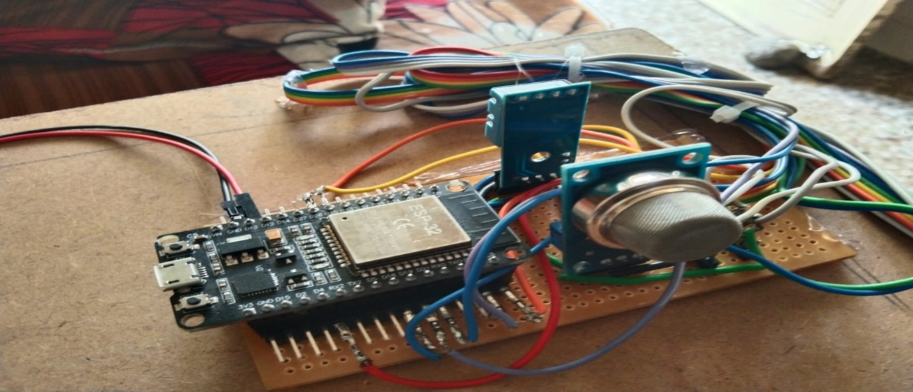
Fig 6.1 : Top view of The project

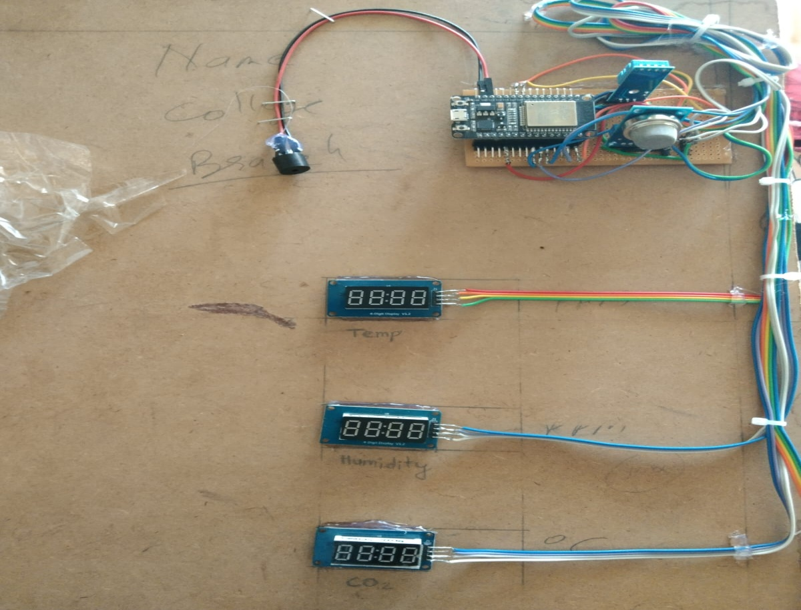
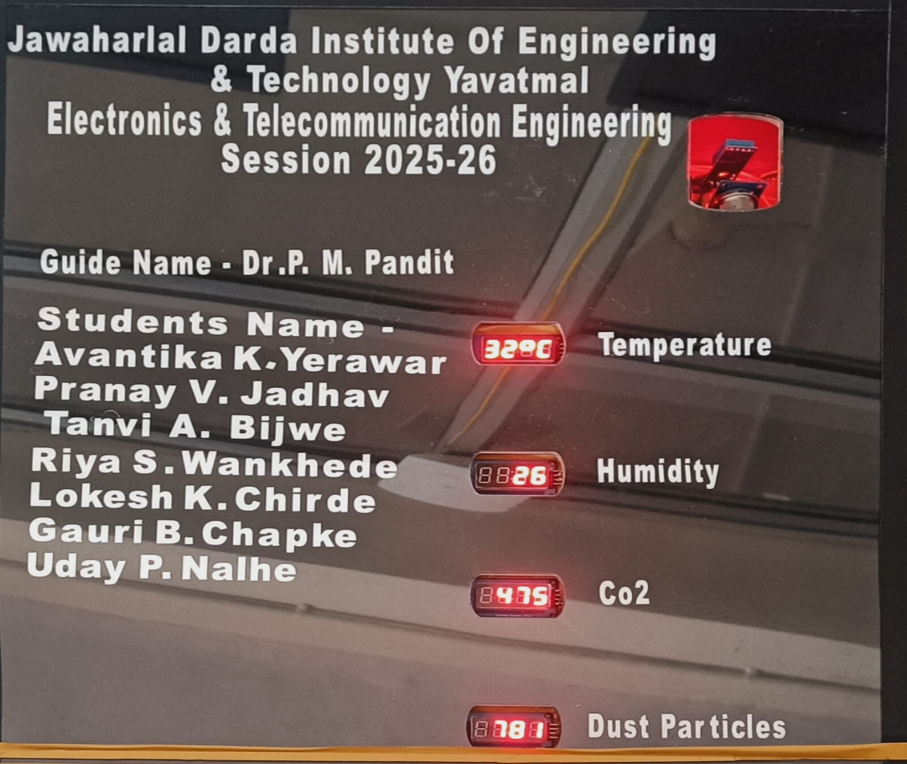
Fig 6.2 : Experimental setup of the proposed system

CHAPTER 7

Advantages

Advantages

- Real-Time Monitoring: Continuously tracks environmental parameters, enabling immediate detection of unsafe conditions.
- Early Alert System: Threshold-based buzzer alerts help prevent exposure to harmful gases and poor air quality.
- Cost-Effective: Built using affordable components like ESP32, MQ sensors, and DHT11.
- Portable and Easy to Deploy: Battery-operated and compact design allows installation in multiple locations.
- Low Maintenance: Simple embedded system design with minimal upkeep requirements.
- Multi-Parameter Monitoring: Monitors CO₂, dust particles, temperature, and humidity simultaneously, providing a comprehensive environmental overview.

CHAPTER 8

Applications

Applications

- Indoor Air Quality Monitoring: Homes, offices, classrooms, and laboratories to ensure healthy indoor conditions.
- Industrial Environments: Factories and workshops to detect gas leaks, dust, and unsafe temperature/humidity levels.
- Environmental Research: Collects data for studies on air pollution, climate, and environmental safety.
- Smart Buildings: Integrates with embedded systems to automate ventilation or alert systems based on air quality.
- Healthcare Facilities: Monitors critical environmental parameters to maintain safe conditions for patients.
- Public Spaces: Airports, malls, and metro stations for monitoring indoor air quality and improving public safety

CHAPTER 9

Future Scope

Future Scope

The proposed real-time environmental monitoring system can be significantly enhanced and expanded in future developments. One major improvement is the integration of IoT technology, enabling remote monitoring, cloud-based data storage, and access to environmental data from anywhere via web or mobile applications. The system can also be upgraded to include additional sensors for detecting harmful gases such as CO, NO₂, and PM2.5, making it suitable for both indoor and outdoor air quality monitoring. By incorporating machine learning algorithms, the system could analyze trends in environmental parameters and predict potential hazards, allowing proactive measures for pollution control and health safety. Furthermore, the monitoring system can be linked with automated control mechanisms such as smart ventilation, air purifiers, or alarm systems for immediate corrective action. These enhancements would make the system more intelligent, scalable, and adaptable for applications in smart homes, offices, industrial plants, and public spaces, contributing to healthier living environments and improved environmental management.

CHAPTER 10

Conclusion

Conclusion

The Real-Time Environmental Parameters Display system successfully demonstrates an efficient and reliable method for monitoring critical environmental factors such as CO₂ concentration, dust particles, temperature, and humidity. By integrating ESP32, MQ2 sensor, and DHT11, the system provides accurate, real-time data and triggers a buzzer alert whenever thresholds are exceeded, ensuring timely warning of unsafe conditions. The project highlights the effectiveness of embedded systems for environmental monitoring, offering a cost-effective, portable, and user-friendly solution. Overall, the system fulfills its objectives by enhancing awareness of environmental conditions, improving safety, and providing a practical platform and advanced predictive features for broader applications in homes, industries, and public spaces.

References

References
- M. Deepshika, S.Ganesh, M.Vikram, A. Deva Kalyan. “Real Time Air Quality Monitoring System”. Anil Neerukonda Institute Of Technology And Sciences. 2021.
- Thanushree D, Vaishnavi G. “Air Quality Detection using Embedded Systems”. International Journal of Advanced Research in Computer and Communication Engineering Vol. 10, Issue 7, July 2021
- Yeshvant.Ba, Mukesh.P, Yokeswaran.T, Vignesh.S. “Real Time Temperature And Humidity Monitoring System”. Student Journal of Electrical and Electronics Engineering Issue No. 1, Vol. 1, 2022.
- Fatima Khan, Amna Khan, Tariq Ali, Tariq Shahzad, Tehseen Mazhar, Sunawar Khan, Muhammad Adnan Khan, Habib Hamam. “IoT-Driven Pollution Detection System for Indoor and Outdoor Environments”. Tech science Press. Volume 86, Issue 2, 9 December 2025.
- Osama Alsamrai, Maria D. Redel-Macias and M. P. Dorado. “Real-Time Intelligent Monitoring of Outdoor Air Quality in an Urban Environment Using IoT and Machine Learning Algorithms”. Appl. Sci. 2025.
- Tanishq Kale1, Mary Matilda2 >”Real – Time Industrial Pollution Data Acquisition and Monitoring System using IoT”. International Research Journal of Engineering and Technology Volume: 08 Issue: 09 | Sep 2021
- Manuel Méndez, Mercedes G. Merayo, Manuel Núñez. “Machine learning algorithms to forecast air quality: a survey”. Artificial Intelligence Review (2023) .
- Darshini Rajasekar, Aravind Sekar, Magesh Rajasekar. “Air Quality Monitoring and Disease Prediction Using IoT and Machine Learning. International Journal of Innovative Research in Computer Science and Technology. Year: 2020, Volume: 8, Issue: 6
- J. Prayudha, A. Pranata and A. Al Hafiz, “Implementation of fuzzy logic method for air quality measurement system in Medan city based on internet of things (IoT)],” JURTEKSI , vol. 4, no. 2, pp. 141-148, 2018.
- N. Middinali and Y. Rahayu, “Development of IoT-based air quality Paper—Real Time System Monitoring and Analysis-Based Internet of Things (IoT) Technology “ Data monitoring system at the University of Riau. JOMFT vol. 6, pp. 1-8, 2019.

Appendix

CODE :
#include <Arduino.h>
#include <TM1637Display.h>
#include "DHT.h"
#include <MQUnifiedsensor.h>

#define Board ("ESP32")
#define Pin (34)
#define Typ ("MQ-135")
#define Voltage_Resolution (3.3)
#define ADC_Bit_Resolution (12)
#define RatioMQ135CleanAir (3.6)
MQUnifiedsensor MQ135(Board, Voltage_Resolution, ADC_Bit_Resolution, Pin, Type);
#define DHTTYPE DHT11
#define DHTPIN 27
#define gaspinanalog 34
#define buzzerpin 13

// Display 1 (Temp)
#define CLK1 4
#define DIO1 26
// Display 2 (Humidity)
#define CLK2 18
#define DIO2 19
//Display3 Gas-Sensor Value
#define CLK3 21
#define DIO3 22
//display smoke value
#define CLK4 23
#define DIO4 25

DHT dht(DHTPIN, DHTTYPE);
TM1637Display display1(CLK1, DIO1);
TM1637Display display2(CLK2, DIO2);
TM1637Display display3(CLK3, DIO3);
TM1637Display display4(CLK4, DIO4);

const uint8_t degree[] = { SEG_A | SEG_B | SEG_G | SEG_F };
const uint8_t letterC[] = { 0b00111001 };

void setup() {
Serial.begin(9600);
dht.begin();
display1.setBrightness(0x0a);
display2.setBrightness(0x0a);
display3.setBrightness(0x0a);
display4.setBrightness(0x0a);
pinMode(13, OUTPUT);

// Optional: clear displays initially
display1.clear();
display2.clear();
display3.clear();
display4.clear();

MQ135.setRegressionMethod(1);
MQ135.init();
Serial.print("Calibrating MQ-135... Please wait.");
float calcR0 = 0;
for (int i = 1; i <= 10; i ++) {
MQ135.update();
calcR0 += MQ135.calibrate(RatioMQ135CleanAir);
}
MQ135.setR0(calcR0 / 10);
Serial.println(" Done!");

if (isinf(calcR0))
{ Serial.println("Error: Connection issue. Check wiring.");
while (1);
}

if (calcR0 == 0)
{ Serial.println("Error: R0 is 0. Check wiring.");
while (1);
}

}

void loop()
{
delay(3000);

//for temperature and humidity
float h = dht.readHumidity();
float t = dht.readTemperature();

//for smoke detection
float sensrval = analogRead(gaspinanalog);

MQ135.update(); // Read the sensor

// Detect CO2
MQ135.setA(110.47); MQ135.setB(-2.862);
float CO2 = MQ135.readSensor() + 400; // +400 for atmospheric baseline

//Check if reads failed
if (isnan(h) || isnan(t)) {
Serial.println("Failed to read from DHT sensor!");
return; // Skip this loop if error
}
//seial monitoe printing

Serial.print("Temperature = ");
Serial.print(t);
Serial.println("°C");
Serial.print("Humidity = ");
Serial.print(h);
Serial.println("%");
Serial.print("Sensorvalue: ");
Serial.println(sensrval);
Serial.print("CO2: ");
Serial.print(CO2);
Serial.println(" ppm | ");

//Display Temperature
display1.showNumberDec((int)t, false, 2, 0);

display1.setSegments(degree, 1, 2); // Degree
display1.setSegments(letterC, 1, 3); //C
//
// int displayValue = (int)round(t * 100);
// display1.showNumberDecEx(displayValue, 0x40, false, 4, 0);

// Display Humidity
display2.showNumberDec((float)h); // Display humidity value

//display co2 values
display3.showNumberDec((float)CO2);
display4.showNumberDec((int)sensrval); //Display smoke level

if (sensrval > 1900 || t > 36)
{digitalWrite(13, HIGH);
delay(3000);
digitalWrite(13, LOW);
}
else {
digitalWrite(13, LOW);
}
}

This above program represents the entire software process from starting to end.

students details
Sr. No. | Details | Students
1. | Name: Avantika Kishor Yerawar  E-Mail: avantikayerawar517@gmail.com  Contact: 8999874961 | 
2. | Name: Riya S. Wankhede  E-Mail: riyawankhede019@gmail.com  Contact: 9850083527 | 
3. | Name: Lokesh K. Chirde  E-Mail: lokeshchirde@gmail.com  Contact: 8379926159 | 
4. | Name: Tanvi A. Bijwe  E-Mail: tanvibijwe18@gmail.com  Contact: 8625828941 | 
5. | Name: Pranay Vishwanath Jadhao  E-Mail: pranayjadhao@gmail.com  Contact: 9067028730 | 
6. | Name: Uday P. Nalhe  E-Mail: udaynalhe94200@gmail.com  Contact: 9561727665 | 
7. | Name: Gauri B. Chapke  E-Mail: chapkegauri@gmail.com  Contact: 9322618735 | 



Project Members

Publication
And Certificates

